
GRADE: VIII  Date: | TERM 1(2023-24)  SCIENCE | MARKS: 40  TIME: 2 hrs

NAME:
SECTION:
Q.No | ANSWERKEY |  | Marks
1 | Cellulose |  | 1
2 | Potassium |  | 1
3 | Earthworm |  | 1
4 | Chromium |  | 1
 | FILL IN THE BLANKS
5 | Polymerisation |  | 1
6 | Alloys |  | 1
7 | Plasma membrane |  | 1
8 | Umblical cord |  | 1
9 | Electro refining |  | 1
 | NAME THE FOLLOWING
10 | Nylon |  | 1
11 | Magnesium |  | 1
12 | Mitochondria |  | 1
13 | Testes |  | 1
14 | Copper |  | 1
 | STATE TRUE OR FALSE
15 | T |  | 1
16 | F |  | 1
 | MATCH THE FOLLOWING
17 | Polyester - PET |  | 1
18 | Sulphur - Vulcanising rubber |  | 1
19 | Oviduct - Fallopian tube |  | 1
20 | Anode - Electrode |  | 1
 | SECTION B
 | VERY SHORT ANSWER QUESTIONS
21 | Destruction of metals. Alloying, electroplating, galvanizing, providing an extra coating. |  | 2
22 | 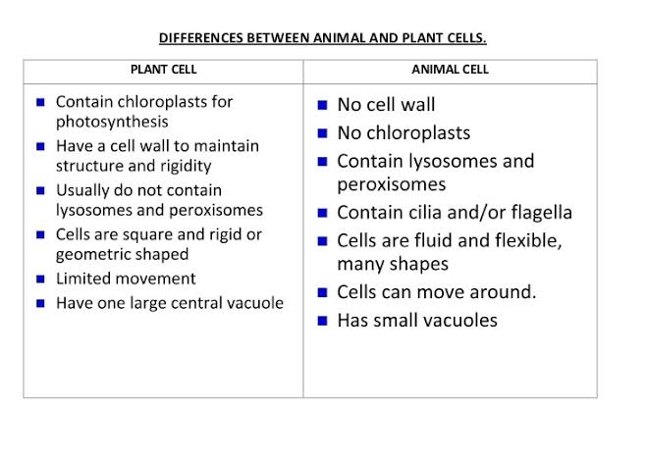 |  | 2
23 | Reproduction is a biological process by which an organism reproduces an offspring that is biologically similar to the organism. Reproduction enables and ensures the continuity of species, generation after generation. |  | 2
 | SHORT ANSWER QUESTIONS
24 | A child's biological sex (male or female) is determined by the chromosome that the male parent contributes. Males have XY sex chromosomes while females have XX sex chromosomes; the male can contribute the X or Y chromosome, while the female must contribute one of their X chromosomes. If the child born get XX chromosomes then it’s a male child and if the chromosome is XY it will be a female child. |  | 3
25 | Obtained from plants and animals  Take more time to dry  Some get wrinkled  Could shrink  Not resistant to insects  Very comfortable  Bleed colour | Made by man from coal, petroleum or wood  Easy to wash and dry  Do not wrinkle  Do not shrink  Resistant to insects  Not always comfortable  Do not bleed colour | 3
26 | ANSWER AND LABEL THE DIAGRAM |  | 4
 | 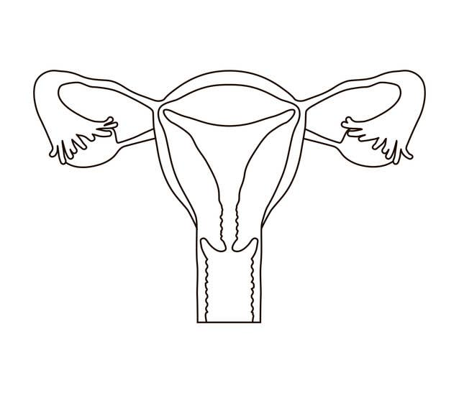
 | - Ovary
- Fallopian tube
- Uterus
- Vagina
 | LONG ANSWER QUESTION
27 | List two uses each of the following  - Most copper is used in electrical equipment such as wiring and motors.  It also has uses in construction and industrial machinery  - Zinc uses range from metal products to rubber and medicines.  Zinc is also used in alloys such as brass, nickel silver and aluminium solder  - Being a semiconductor, the element is put into use for making transistors.  Silicon is widely used in computer chips and solar cells.  - Oxygen is used up by living beings in respiration process.  It is used for burning of fuels. |  | 4
 | THE END

